**CloudMarket**

## Kaustubh Kulkarni (kaustubh.kulkarni@sjsu.edu)

## Pranav Dhapke (pranav.dhapke@sjsu.edu)

## Tanvi Deo (tanvi.deo@sjsu.edu)

## Nikhil Chavan (nikhil.chavan@sjsu.edu)

*Charles Davidson College of Engineering @San Jose State University One Washington Square, San Jose, California -95192-0080, USA*

## Project Introduction Video

## <https://www.youtube.com/watch?v=7fymWP2sd-c&feature=youtu.be>

# Abstract

*Nowadays all of us have hectic schedules and we tend to forget the status of required grocery. How about an app that will manage your requirements of grocery without your intervention? Cloud Market will collect data automatically and will notify the specified grocery store about your grocery needs. After getting the notification, the store can send the required grocery to your place. This will automate entire process of grocery management which will make sure that you are never out of groceries. On the other hand the grocery store can analyze your pattern of purchase and can use this data for better inventory management.*

*Keywords: CloudMarket, Inventory Management.*

# Introduction

CloudMarket will provide effective automated inventory management solution. To manage the inventory the company needs to assign a dedicated department for inventory follow up which uses lot of resources. CloudMarket can be used as a cloud application which will notify the vendors regarding status of inventory. This will allow vendors to analyze the demand of required goods which will result in better inventory management system. The application will also keep track of particular item and will generate the notification when count of particular item goes below the threshold. Cloud Market will always ensure that you are never out of stock..

We have analyzed data and provided detailed information for store owner to understand need and demand better. We also provided graphical data analysis available to store owner. This paper will give you detailed description about various functionalities we have implemented in this application.

# Analysis

We have encountered shortcomings of grocery items in our day-to-day activities. And, we came upon an idea that we need to build an application to overcome this shortcoming. CloudMarket is useful for everyone wiz. Customers, Store Owners.

CloudMarket is developed with a motto to help customers buying grocery and store owners with managing inventory. Customers don’t need to go to any grocery store and needn’t worry for it as well. CloudMarket application will take care of their groceries. We have provided customers to access their account on CloudMarket to select each grocery item as per their needs. They can set threshold for every grocery item. Whenever item count falls below threshold value, that item will be shipped to customer without any hustle. On other side, store owners will be able to manage store’s inventory efficiently. It will also allow to manage grocery items as per customer’s need. This will allow store owner to manage brand products accordingly.

The best part of CloudMarket is that it helps people to make choice between different categories of product. They can shift their requirements by changing the threshold value for every item. The store owner will be able to know about the customer’s requirements for each and every item. This will make store owner to respond accordingly. Every time when customer changes the requirements of products then the store owner will be notified through CloudMarket application. This automates the entire process of getting groceries from any grocery store.

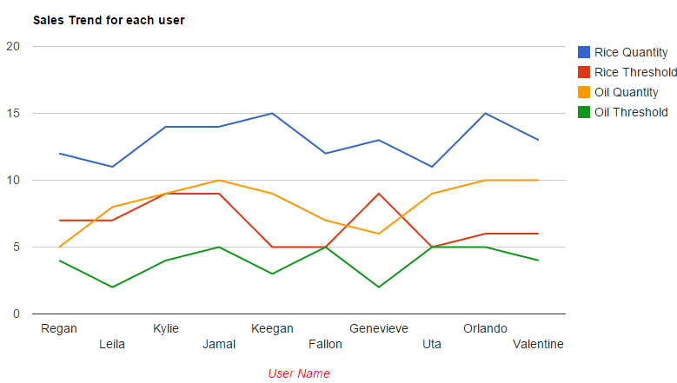

Sales Trend for each user: Line Chart

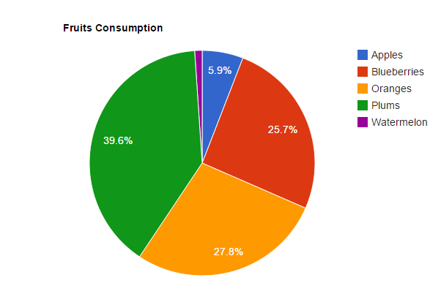

Fruits Consumption: Pie Chart

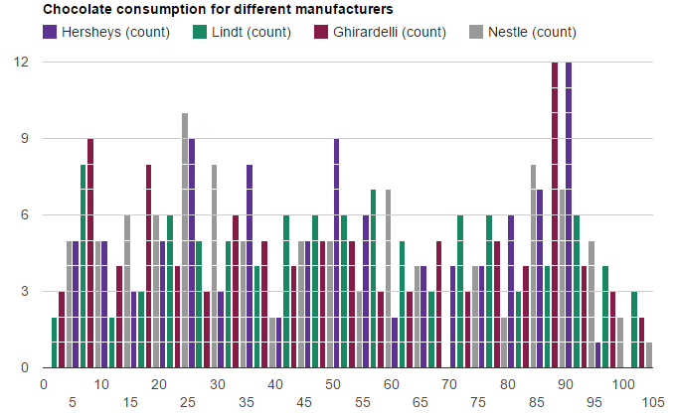

Chocolate Consumption for different manufacturers: Histogram

## **3. Impact on Store Owners**

All of the above info graphs are available to store owner while using cloud market. So store owner will know which product of what type is consumed more where and when. Data Analysis is the biggest advantage for store owners. Along with that he will have knowledge of all the customers present on the application and using the cloud market application. Real time data will be available to store owner which will be a beneficial tool if used properly. With the real time data he can plan the things accordingly.

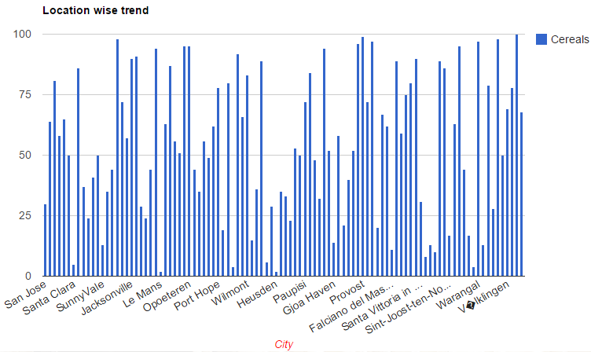

Location wise Sales trend for Cereals: Bar Graph

## **4. Impact on Customers**

Cloud Market will have a big impact on customers. It will make the process of grocery shopping automated. Customers will be able to access it from anywhere. They will be also be able to add products to their grocery from home making grocery shopping very easier. One more advantage they get for using cloud market is that all the groceries will be delivered to them at their doorstep according to their requirements.

## **5. Solutions**

There are no applications present that tried to make grocery shopping process into automated process. This application doesn’t just automate this process but allows customers to get these stuff according to his needs and requirement. It also allows customers to change their requirements per week or per month or even per day! And the fact is that this application is as much useful to store owners as customers. A lot of data analysis provided to store owners makes his job easier and allows him to manage his inventory better.